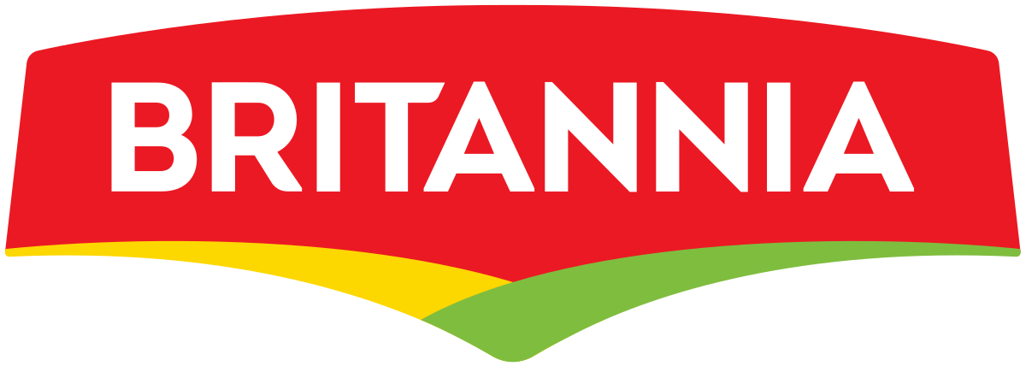

**Industry overview of Britannia industries**

**Introduction -** Britannia Industries Limited is an Indian company specialised in food Industry, part of the Wadia Group headed by Nusli Wadia. Founded in 1892 and headquartered in Kolkata, it is one of India's oldest existing companies and best known for its biscuit products. The company sells its Britannia and Tiger brands of biscuits, breads and dairy products throughout India and abroad Beginning with the circumstances of its takeover by the Wadia Group in the early 1990s, the company has been mired in several controversies connected to its management. However, it still has a large market share and it is profitable.

The company was established in 1892 by a group of British businessmen with an investment of ₹295. Initially, biscuits were manufactured in a small house in central Kolkata. Later, the enterprise was acquired by the Gupta brothers, mainly Nalin Chandra Gupta, an attorney, and operated under the name "V.S. Brothers." In 1918, C.H. Holmes, an English businessman based in Kolkata, was taken on as a partner and The Britannia Biscuit Company Limited was launched. The Mumbai factory was set up in 1924 and Peek Freans UK, acquired a controlling interest in BBCo. Biscuits were in high demand during World War II, which gave a boost to the company's sales. The company name was changed to the current "Britannia Industries Limited" in 1979. In 1982, the American company Nabisco Brand Inc, acquired the parent of Peek Freans and became a major foreign shareholder.

**Size of the Industry**

Britannia Industries is one of India’s leading food companies with a 100-year legacy and annual revenues in excess of Rs. 9000 Cr. Britannia is among the most trusted food brands, and manufactures India’s favourite brands like Good Day, Tiger, NutriChoice, Milk Bikis and Marie Gold which are household names in India. Britannia’s product portfolio includes Biscuits, Bread, Cakes, Rusk, and Dairy products including Cheese, Beverages, Milk and Yoghurt. Britannia is a brand which many generations of Indians have grown up with and our brands are cherished and loved in India and the world over. Britannia products are available across the country in close to 5 million retail outlets and reach over 50% of Indian homes. The company’s Dairy business contributes close to 5 per cent of revenue and Britannia dairy products directly reach 100,000 outlets. Britannia Bread is the largest brand in the organized bread market with an annual turnover of over 1 lac tons in volume and Rs.450 crores in value. The business operates with 13 factories and 4 franchisees selling close to 1 mn loaves daily across more than 100 cities and towns of India.

We have a presence in more than 60 countries across the globe. Our international footprint includes presence in Middle East through local manufacturing in UAE and Oman, are the No 2 biscuit player in UAE with a strong contention to leadership and have a similarly strong market position in the other GCC countries. We are also the market leaders in Nepal and are in the process of investing a manufacturing facility in the country. Our foot print spreads across North America, Europe, Africa and South East Asia through exports and we are investing in a state- of- the- art facility in Mundra SEZ, Gujarat, to service the exports markets.

|  |  |
| --- | --- |
| **Formerly** | **Britannia Biscuit Company Limited** |
| Net income | ₹1,402.63 crore (US$180 million) (2020) |
| **Total assets** | **₹7,253.34 crore (US$950 million) (2020)** |
| Number of employees | 4,480 (as on 31 March 2019) |

**Major players in the industry**

* Britannia Industries Ltd
* Parle products Pvt. Ltd
* ITC Ltd
* Unibic foods India Ltd
* Priya Gold: Surya food Pvt Ltd

**Market share of major players**

1. **Britannia Industries Ltd** – Market share of Britannia is 28 %
2. **Parle products Pvt Ltd** – Market share of Parle products is 27%
3. **ITC Ltd** – The market share of ITC Ltd is 11%
4. **Unibic foods India Ltd** – Market share of Unibic foods India Ltd is 10%
5. **Priya Gold: Surya food Pvt Ltd** – Market share of Priya gold Pvt Ltd is 8%

**Challenges faced by the Industry**

1. **The Tax structure : Earlire & Now** – The current market share of biscuit industry stands at staggering 20,000 cr. This is the industry which is still ruled by Indian players, even the industry leaders such as Parle, Britannia are Indian companies. The recently rolled out GST is touted to create the biggest hurdle.  Biscuit is a mass consumption food item but has been suffering due to unjustified imposition of Goods & Service Tax (GST) at a very high rate of 18%. As per Agarwal, “The government has mistakenly understood as a premium product by placing it in the higher tax slab denying level playing field for biscuits and similar products.
2. **Cost Escalation** – Apart from GST, high inflation on raw material and packaging material is yet again marring the growth of biscuit industry. Moreover, the recent proposals from government to revise the minimum purchase price of wheat, sugar in order to relief the farmers will ultimately affect the pricing of biscuits. Furthermore, in order to comply with GST slab manufactures will be forced to increase the price. Speaking on same, Pankaj Agarwal, CEO, Bonn Biscuits said,” Biscuit Industry is subjected to escalation in cost of inputs/ingredients due to higher cost of transportation, fuel, packaging, wages etc.
3. **Retail Challenges** – Biscuit is an item which is still largely sold by the general traders. “We are facing a lot of challenges at retail level, when a shopkeeper sold different food items marked with different GST slabs then it becomes an arduous task to bill or sale. And, this is one of the biggest deterrents of switching to plastic money transaction to purchase biscuits. That is the reason we are requesting the government to put all food items on similar GST slab.” Said Shekhar Agarwal, Director, Surya Food & Agro Ltd. (Priya gold Biscuits). Moreover, apart from small cookies manufacture nobody dares to initiate direct retail. “Nobody can survive by opening their own direct stock since the size of industry is huge, it is really not possible for vast companies to have their exclusive retail distribution.